Validación del estado actual del proyecto

1. Casos de prueba
2. Validación de usuarios (CSUQ o SUS)

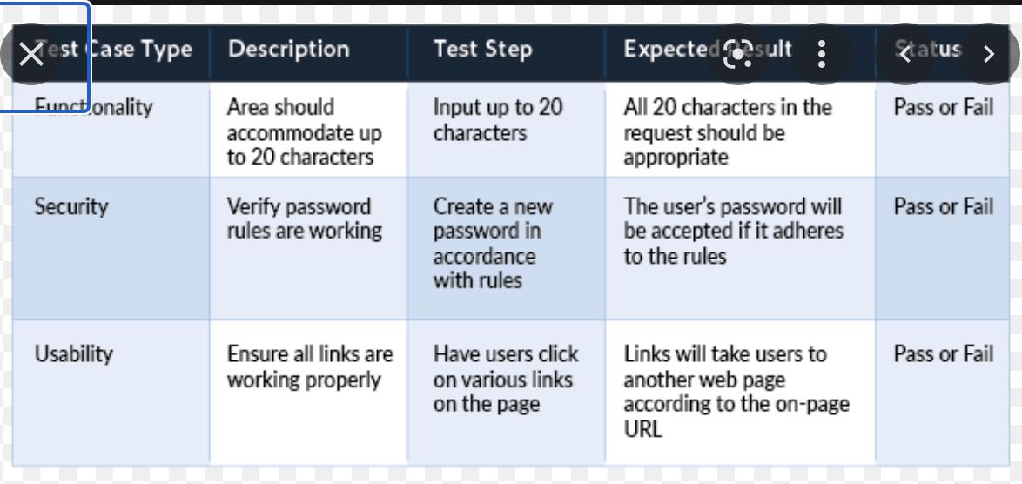

All buttons work

Log-in

Register

See map

See a list of services and products around you

| Test Case Type | Description | Test step | Expected result | Status |
| --- | --- | --- | --- | --- |
| Functionality | The user should be able to register within the app |  |  | Pass |
| Functionality | The user should be able to log in onto the app |  |  | Pass |
| Functionality | The user should be able to see the map and a ratio |  |  | Pass |
| Functionality | The user should be able to see a list of products and services around him |  |  | Pass |
| Usability | All buttons and links on the app should work properly |  |  | Pass |
| Security | The user can access their account only by password |  |  |  |

**Validación de usuarios (CSUQ o SUS)**